SPEAR

Surveying and Planning through Electronic Applications and Referrals

SPEAR Release Notes

Release 5.4

The following functional change to SPEAR has been included in Release 5.4:
 | Users Impacted | Feature | Description
 | Applicant Contact  All users | Integration of ePlan Portal with SPEAR  CR5335 | The ePlan Portal will be integrated with SPEAR and made available to all SPEAR users. The functionality of the ePlan Portal includes:  - Surveyors to upload their Single CAD Format Files (SCFF) to the ePlan Portal for validation and to convert them to ePlans, using the inbuilt ePlan Editor to add plan details and attributes.  - Additional data population when creating ePlans from SCFF – e.g. surveyors registration number, surveying firm logo etc  - Automatic preservation of metadata between ePlan versions  - All files uploaded or created using the ePlan Portal will be saved to the cloud and displayed in a dashboard for users to access and download. This includes SCFF-compliant DXF, ePlan LandXML, Owners Corporation XLSX spreadsheet, and Enhanced Diagram JSON files.  - Surveyors to retrieve and use their saved ePlans directly within SPEAR  - Surveyors can justify ePlan validation errors or warnings for the attention of plan examiners within the ePlan Portal  - Other SPEAR users in an application can use the ePlan Portal to view the ePlan  - 24/7 availability of the ePlan Portal  The following changes have been made to SPEAR to support the ePlan Portal:  - All surveying organisations are now able to supply ePlans. This no longer needs to be configured for each organisation  - A new ‘Select ePlans’ screen in SPEAR allows surveyors to retrieve saved ePlans from the ePlan Portal when creating a SPEAR application or adding a new plan version to SPEAR.  - The ePlan Public Services page has been removed and all icons and links to ePlan Services have been replaced with the ePlan Portal icon. All ePlan functionality, including the Visualisation Enhancement Tool, is now accessible via the ePlan Portal.  - Previously, a certified PDF could not be replaced with an ePlan, but surveyors can now replace a certified PDF plan with an ePlan through the re-certification or requisition process.
 | All signing users | Signing Application phased rollout  Solution Design  CR5555 | A new version of the SPEAR Signing Application is now available. This update is part of a regular security upgrade and requires all signing users, including those that have their certificates installed on a token, to install the new version by 26 January 2022.  To install the new signing software:  - Click on the ‘download singing application’ link available from the top left of any signing screen (or test signing screen)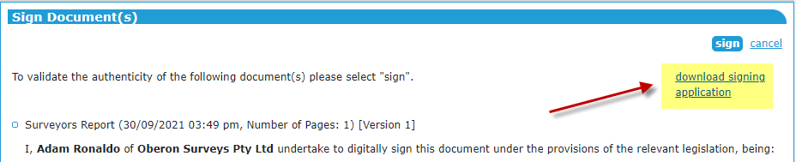  - Download and run the file:  - If you have successfully updated the signing software, you will see a version number displayed in the lower left corner of the Signing Conformation window when you sign (the older version of the software will not present any version information).  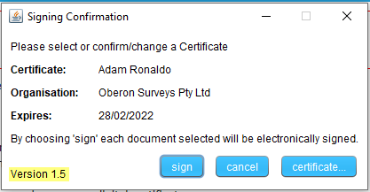  To facilitate the update please note:  - Local software installation permissions may be required, please work with your own IT support if you are unable to install the software  - All computers that you use to sign from (home and office) will need to have the latest SPEAR Signing Application installed.  - After 26 January 2022, signing will no longer be possible if you have NOT installed this latest version. Any users attempting to sign using the older version of the SPEAR Signing Application will be presented with a message to download and install the new version.  It is strongly recommended that signing users update their signing application as soon as possible from the SPEAR 5.4 Release (18 October 2021).
 | Consenting Party Lodging Party | Improvements to title checking for MSA  CR5525 | SPEAR will now determine if an application requires consent from DELWP’s Melbourne Strategic Assessment team by using the most up-to-date Volume/Folio information available from the lodging party:  - At Statement of Compliance (SOC), if the lodging party has completed the Application Lodgment Form before SOC.  - When the Application Lodgment Form is saved if the Application Lodgment Form is completed after SOC. In this case, SPEAR will perform the existing check at SOC using the title information supplied by the surveyor, and a second check when the Application Lodgment Form is saved.  This change ensures that applications requiring MSA consent are identified as early as possible, once the up-to-date Volume/Folio(s) are provided in SPEAR.

